Platform Architecture and Interface Documentation

Architecture of Zoho Creators

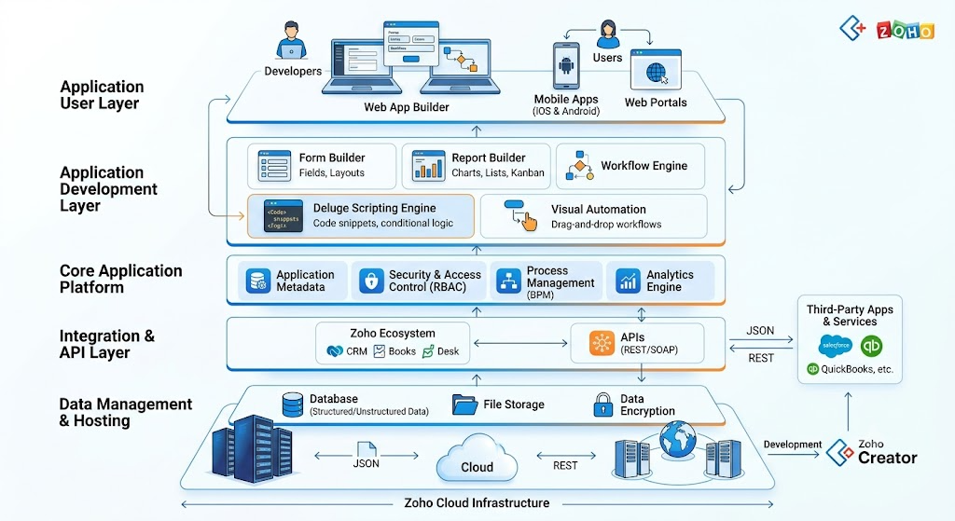

Introduction
This document provides a comprehensive overview of the Zoho Creator platform architecture and its user interface components. It explains the purpose, functionality, and practical applications of the major features available within the platform. The documentation is intended to help users understand how different modules work together to support low-code application development, workflow automation, data management, and business process optimization.
Each feature is described with its purpose, detailed functionality, key capabilities, business benefits, real-world use cases, and important notes. This structured approach enables developers, administrators, and business users to easily navigate and understand the platform's capabilities.

Feature Name : Applications
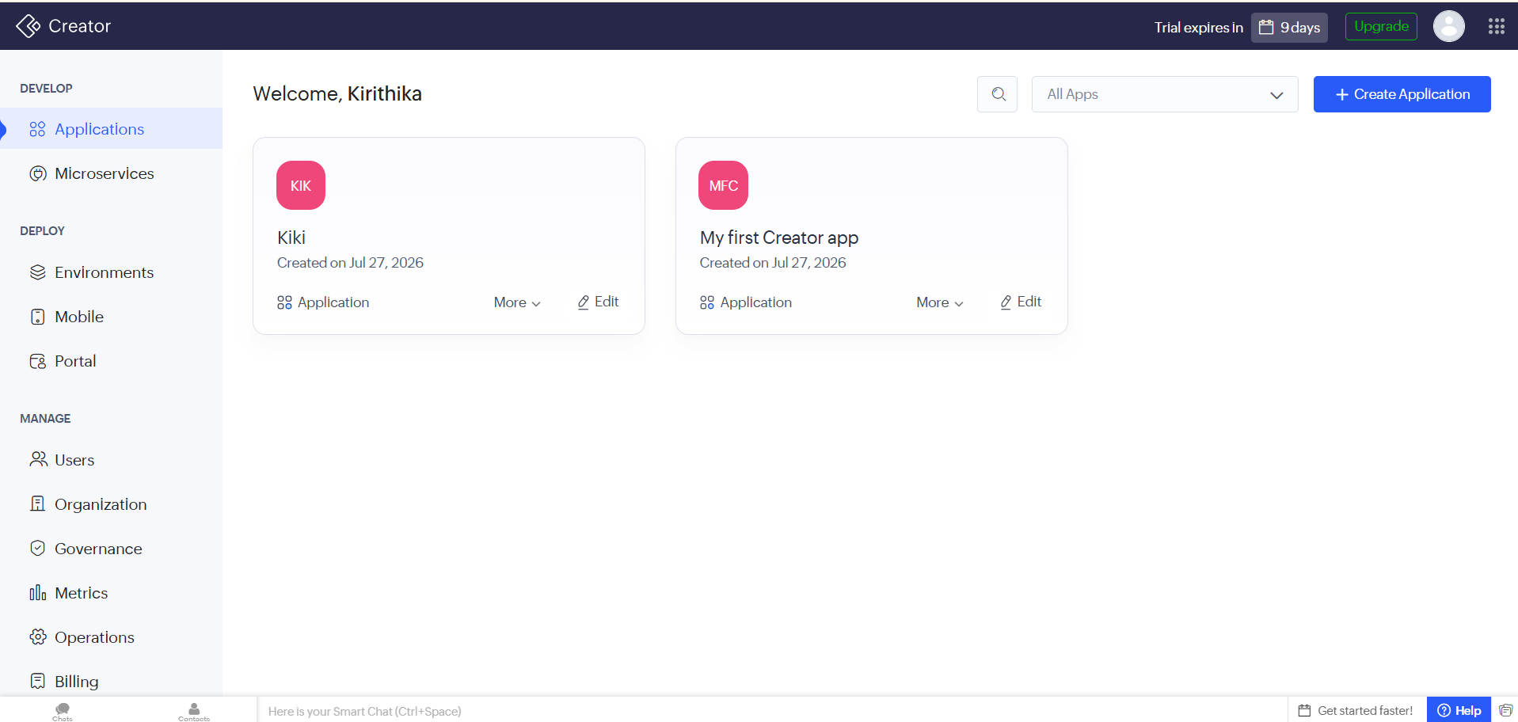

Purpose
The Applications module serves as the central workspace in Zoho Creator where users can create, access, manage, and organize all their low-code applications. It provides a single location for viewing existing applications and initiating the development of new ones.

Description
The Applications page is the primary landing page displayed after signing in to Zoho Creator. It presents all available applications as individual cards, allowing users to quickly identify and access their projects. Each application card displays essential details such as the application name, creation date, and quick actions like Edit, Open, and More Options.
The interface also includes a Create Application button, enabling users to build new applications from scratch or by using pre-built templates. Additional utilities such as the search bar and application filter help users efficiently locate specific applications, especially in organizations managing multiple projects. This centralized dashboard simplifies application management and enhances productivity by providing quick access to all development resources.

Key Functions
- Displays all existing applications in a centralized dashboard.
- Creates new applications using the Create Application option.
- Provides quick access to edit, open, or manage application settings.
- Supports searching and filtering applications for easier navigation.
- Organizes multiple business applications within a single workspace.

Benefits
- Provides a centralized location for managing all applications.
- Simplifies application creation and project organization.
- Improves navigation through search and filtering options.
- Enables faster access to development and management tools.
- Enhances productivity by reducing the time required to locate and manage applications.

Business Use Case
A company developing multiple internal business solutions—such as an Employee Management System, Inventory Tracker, Customer Relationship Management (CRM), and Leave Management System—can manage all these applications from the Applications dashboard. Developers and administrators can quickly access, edit, or deploy the required application without switching between multiple platforms, resulting in improved operational efficiency.

Feature Name : Microservices

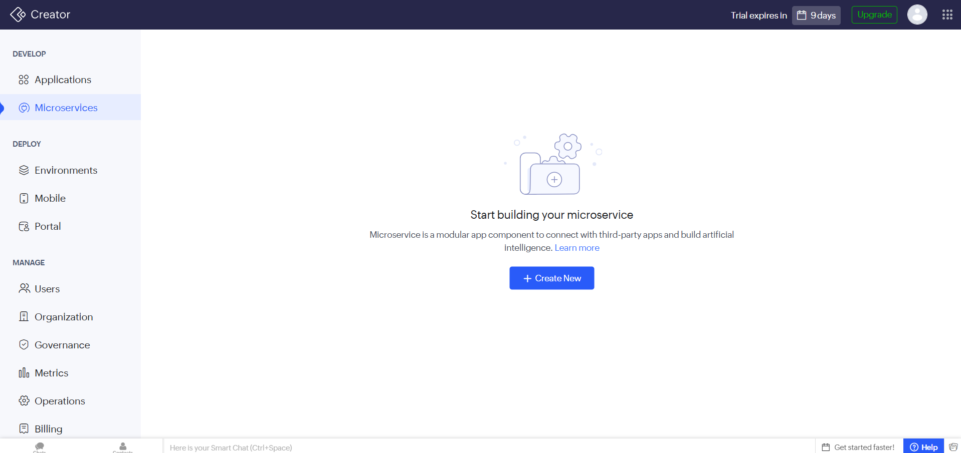

Purpose
The Microservices module in Zoho Creator enables users to build lightweight, modular services that can perform specific business functions independently. These services are primarily designed to integrate with third-party applications, expose APIs, and support intelligent automation without affecting the core application.

Description
The Microservices interface provides a dedicated environment for creating and managing independent service components. Unlike traditional applications, microservices focus on a single functionality and can be reused across multiple applications or external systems. This modular approach improves flexibility, scalability, and maintainability in application development.
Users can create a new microservice using the Create New button and configure it to interact with external platforms, process data, execute custom logic, or provide API endpoints. Since each microservice operates independently, updates or modifications can be made without disrupting the main application, making it suitable for modern business solutions and integrations.

Key Functions
- Create standalone microservices for specific business operations.
- Integrate with third-party applications and external APIs.
- Execute independent business logic and automation processes.
- Build reusable service components across multiple applications.
- Support scalable and modular application architecture.

Benefits
- Promotes modular and scalable application development.
- Simplifies integration with external systems and services.
- Enables independent deployment and maintenance of services.
- Reduces the impact of updates on the main application.
- Improves flexibility and reusability of business functionalities.

Business Use Case
A retail company can develop separate microservices for payment processing, inventory synchronization, and customer notifications. Each service operates independently and communicates with external platforms such as payment gateways, warehouse systems, or messaging services. This approach allows each component to be updated or scaled without affecting the overall business application.

Feature Name : Environments

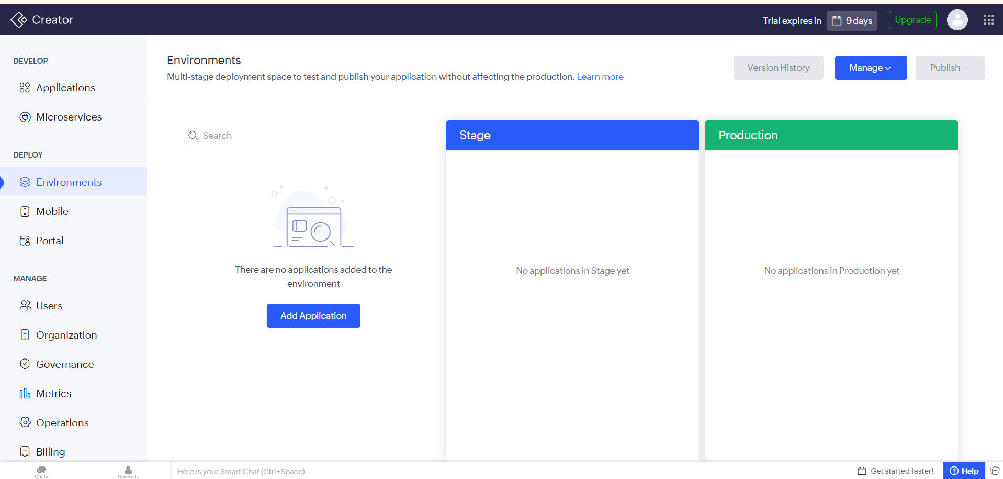

Purpose
The Environments module in Zoho Creator provides a multi-stage deployment framework that enables developers to test, validate, and publish applications without directly affecting the live production environment. It ensures safe application development by separating testing and production workflows.

Description
The Environments interface is designed to support application lifecycle management by providing dedicated deployment stages, such as Stage and Production. Developers can first deploy applications to the Stage environment, where new features, bug fixes, and updates are thoroughly tested before being released to end users. Once testing is completed successfully, the application can be published to the Production environment.
The interface also includes options such as Add Application, Version History, Manage, and Publish, allowing users to control application deployments, monitor different versions, and manage deployment configurations efficiently. This structured deployment process minimizes risks, ensures application stability, and prevents disruptions to business operations.

Key Functions
- Manage multiple deployment environments for applications.
- Deploy applications to the Stage environment for testing.
- Publish validated applications to the Production environment.
- Track application versions using Version History.
- Manage deployment settings and application releases.

Benefits
- Prevents untested changes from reaching live users.
- Supports structured testing and quality assurance.
- Simplifies version management and deployment tracking.
- Reduces deployment risks and application downtime.
- Improves reliability and stability of business applications.

Business Use Case
A software development team updates an Employee Management System with new attendance features. Before releasing the update to employees, the team deploys it to the Stage environment for testing and validation. After confirming that the application functions correctly, the updated version is published to the Production environment, ensuring a smooth and error-free release.

Feature Name : Mobile

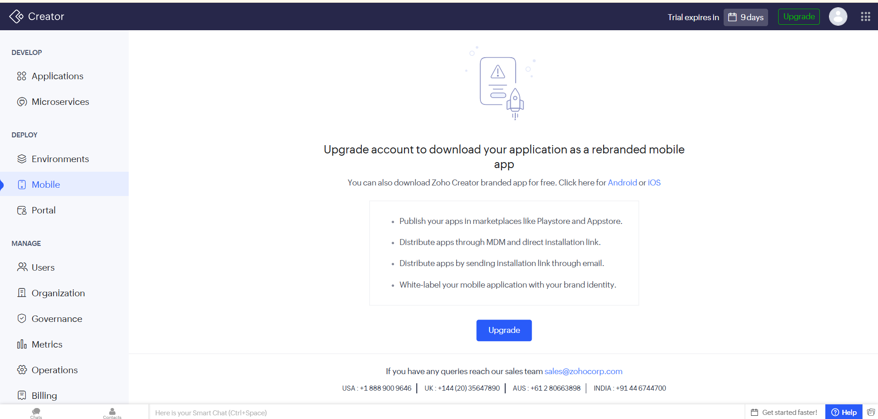

Purpose
The Mobile module enables users to convert their Zoho Creator applications into mobile applications, allowing them to access and use business applications on Android and iOS devices. It also provides options for branding, publishing, and distributing mobile applications.

Description
The Mobile section allows developers to extend their Zoho Creator applications beyond the web by making them available on mobile devices. Users can download applications using the Zoho Creator mobile app or upgrade their account to publish a fully branded mobile application under their own organization.
With a paid subscription, developers can customize the application's branding, publish it on marketplaces such as the Google Play Store and Apple App Store, distribute it through Mobile Device Management (MDM) solutions, or share installation links directly with users. This enables organizations to provide secure mobile access to employees and customers while maintaining their brand identity.

Key Functions
- Access applications through the Zoho Creator mobile app.
- Publish branded mobile applications for Android and iOS.
- Distribute applications through MDM solutions.
- Share application installation links via email or direct download.
- Customize mobile applications with organizational branding.

Benefits
- Enables business applications to be accessed from mobile devices.
- Improves workforce productivity through mobile accessibility.
- Supports enterprise-level mobile application distribution.
- Enhances brand identity with white-labelled mobile applications.
- Provides multiple deployment options for mobile users.

Business Use Case
A field service company develops a maintenance management application in Zoho Creator. Technicians use the Zoho Creator mobile app to update job status, upload photos, and record service reports while working on-site. If the company upgrades its subscription, it can publish the application under its own brand and distribute it exclusively to employees through the Google Play Store, Apple App Store, or an internal MDM system..

Feature Name : Portal

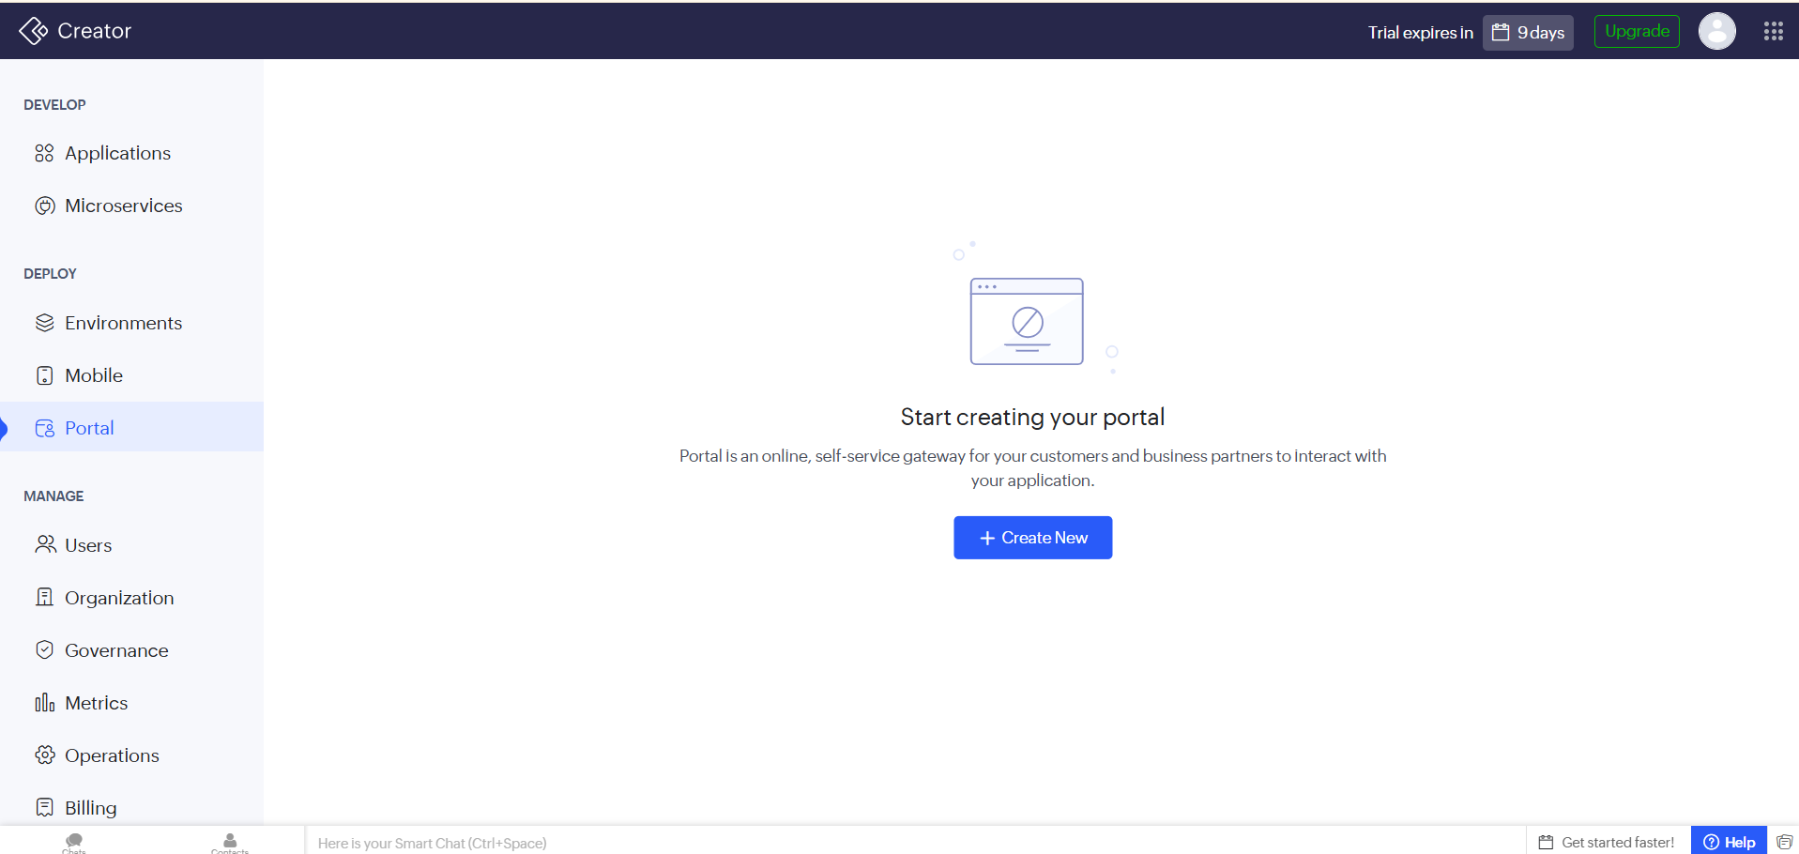

Purpose
The Portal module in Zoho Creator enables organizations to create a secure, self-service portal where customers, vendors, partners, or external users can access applications, submit information, and interact with business processes without requiring direct access to the Creator workspace.

Description
The Portal feature provides an online gateway that allows external users to securely interact with Zoho Creator applications through a dedicated portal. Instead of granting access to the entire application, administrators can configure portals to provide only the necessary features and data based on user roles and permissions.
Users can create a new portal using the Create New option and customize it according to business requirements. The portal supports user authentication, controlled access, and personalized experiences, making it suitable for customer service, partner collaboration, employee self-service, and vendor management. This feature helps organizations securely extend their applications beyond internal users while maintaining data privacy and access control.

Key Functions
- Create secure self-service portals for external users.
- Provide controlled access based on user roles and permissions.
- Enable customers, partners, and vendors to interact with applications.
- Manage portal users and authentication.
- Offer a customized interface for external business interactions.

Benefits
- Extends application access to external stakeholders securely.
- Reduces manual communication through self-service functionality.
- Improves customer and partner engagement.
- Ensures secure access with role-based permissions.
- Enhances operational efficiency by enabling online interactions.

Business Use Case
A university develops a Student Portal using Zoho Creator where students can log in to submit applications, check admission status, upload required documents, and view academic information. Similarly, businesses can create customer or vendor portals to manage service requests, orders, invoices, and support tickets through a single online platform.

Feature Name : Users

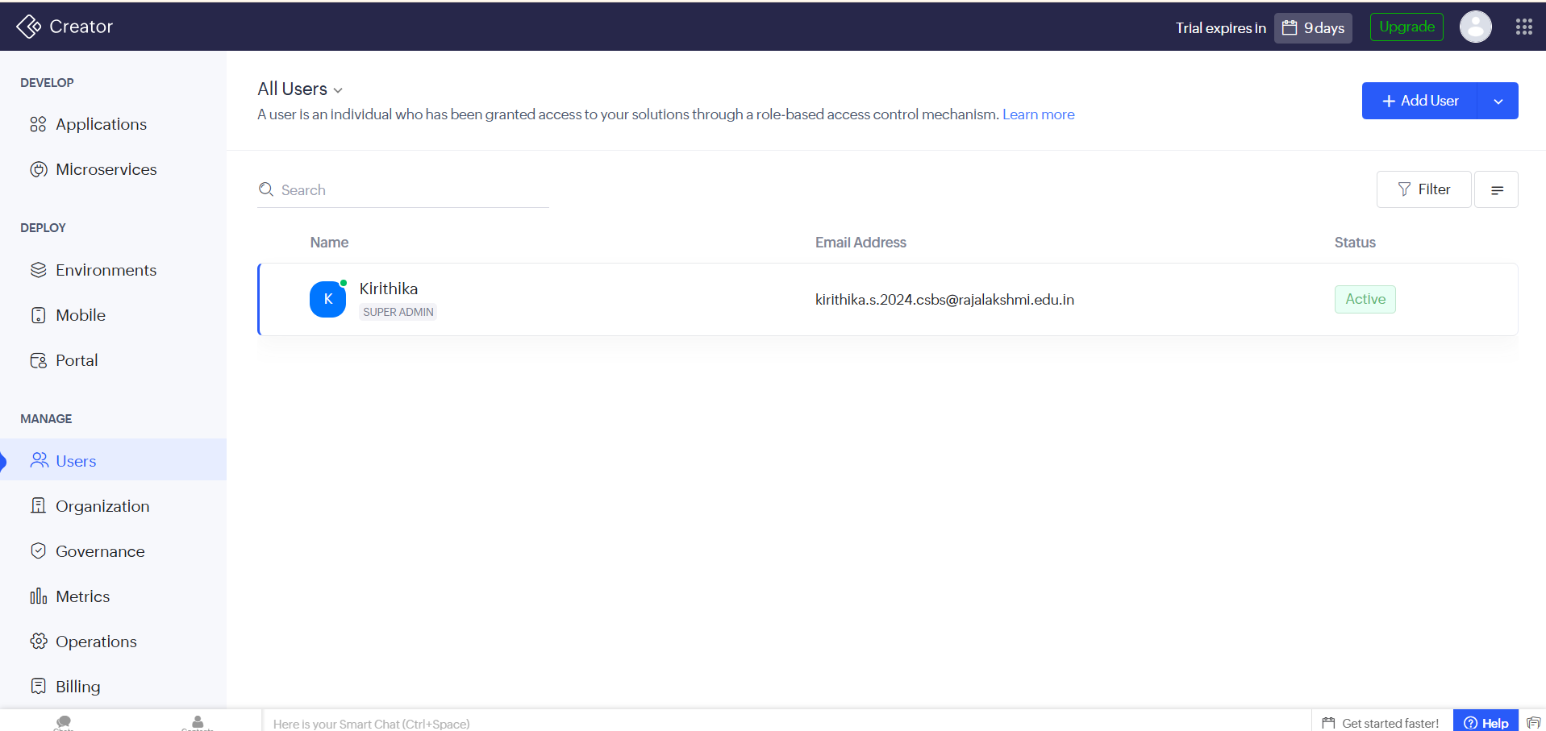

Purpose
The Users module in Zoho Creator is used to manage individuals who have access to applications and organizational resources. It enables administrators to add users, assign roles, control permissions, and monitor user status through a role-based access control (RBAC) mechanism.

Description
The Users interface provides a centralized location for managing all users within a Zoho Creator organization. Administrators can add new users, search for existing users, and filter user records based on specific criteria. The interface displays essential information such as the user's Name, Email Address, Assigned Role, and Account Status, making it easier to monitor and manage user access.
Zoho Creator uses role-based access control (RBAC) to ensure that each user has the appropriate level of access based on their responsibilities. For example, a Super Admin has complete administrative privileges, while other users can be assigned roles with limited permissions. This approach enhances security by ensuring users can access only the applications and features relevant to their roles.

Key Functions
- Add and manage users within the organization.
- Assign roles and permission levels using role-based access control.
- Search and filter users for efficient management.
- View user details such as name, email address, role, and account status.
- Monitor active and inactive user accounts.

Benefits
- Centralizes user and access management.
- Enhances security through role-based permissions.
- Simplifies user administration and monitoring.
- Prevents unauthorized access to applications and data.
- Improves collaboration by assigning appropriate access levels.

Business Use Case
An organization developing an Employee Management System can assign different access levels to its staff. The Super Admin manages the entire application, HR personnel can access employee records, managers can approve leave requests, and employees can view only their personal information. This ensures secure and controlled access to business data.
Feature Name : Organization
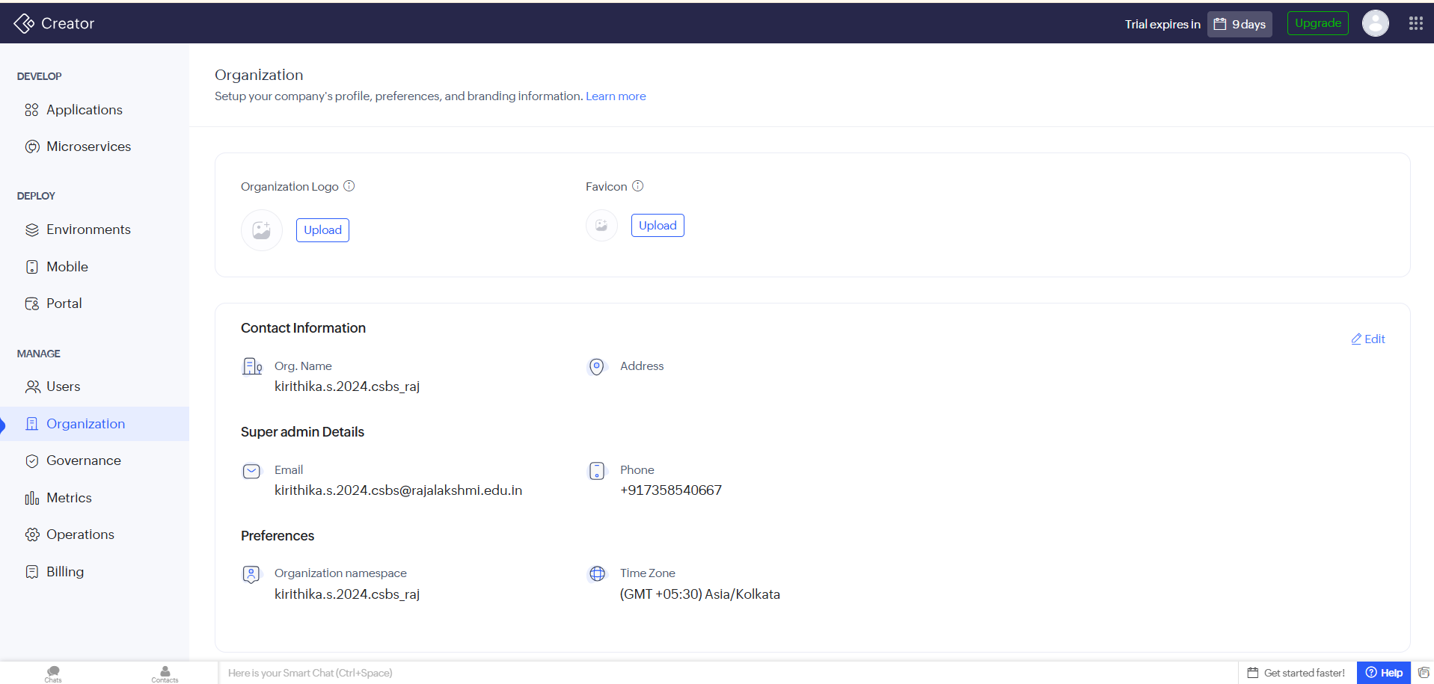

Purpose
The Organization module in Zoho Creator is used to configure and manage an organization's profile, branding, contact information, and system preferences. It serves as the central location for defining the organization's identity and default settings used across all applications.

Description
The Organization interface enables administrators to customize the organization's profile by adding branding elements such as the Organization Logo and Favicon, making applications visually consistent with the company's identity. It also allows users to maintain important organizational details, including the organization name, address, and contact information.
In addition to branding, the module provides administrative settings such as the Organization Namespace and Time Zone, ensuring that applications operate according to the organization's regional and business requirements. Super administrator details, including email and phone number, are also displayed for management purposes. These settings help establish a standardized environment for application development, deployment, and collaboration.

Key Functions
- Configure the organization's profile and branding.
- Upload the organization logo and favicon.
- Manage contact information and administrator details.
- Configure the organization namespace.
- Set the default time zone for all applications.

Benefits
- Establishes a consistent organizational identity across applications.
- Centralizes company profile and administrative settings.
- Simplifies management of branding and contact information.
- Ensures applications follow the correct regional time settings.
- Improves organization-wide consistency and administration.

Business Use Case
A company developing multiple business applications can upload its official logo and favicon to maintain a consistent brand identity across all applications. The administrator can configure the organization's contact details, set the appropriate time zone for business operations, and define the organization namespace, ensuring that all users work within a standardized and professionally branded environment.

Feature Name : Governance

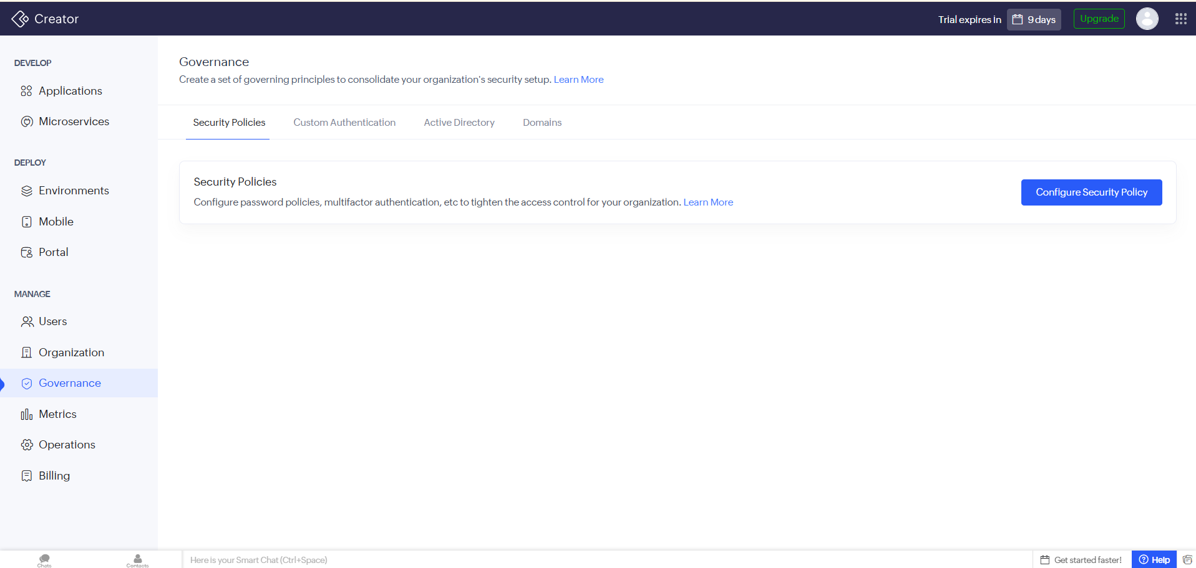

Purpose
The Governance module in Zoho Creator enables organizations to establish and enforce security policies, authentication methods, and access control mechanisms. It helps administrators maintain a secure application environment by defining organization-wide governance and security standards.

Description
The Governance interface provides a centralized platform for managing the organization's security configuration. It includes features such as Security Policies, Custom Authentication, Active Directory, and Domains, allowing administrators to strengthen access control and protect organizational resources.
Using the Security Policies section, administrators can configure password requirements, enable multi-factor authentication (MFA), and define authentication rules to enhance account security. Integration with Active Directory allows organizations to manage users through existing enterprise directories, while Custom Authentication supports integration with external authentication providers. Domain management further helps control access by defining trusted organizational domains, ensuring that only authorized users can access business applications.

Key Functions
- Configure organization-wide security policies.
- Set password policies and authentication requirements.
- Enable Multi-Factor Authentication (MFA) for enhanced security.
- Integrate with Active Directory for centralized user management.
- Configure custom authentication methods and trusted domains.

Benefits
- Strengthens organizational security and access control.
- Protects applications and sensitive business data.
- Simplifies centralized user authentication and management.
- Supports enterprise identity management through Active Directory.
- Helps organizations comply with security and governance standards.

Business Use Case
A financial organization can use the Governance module to enforce strong password policies, require multi-factor authentication for all employees, and integrate Zoho Creator with the company's Active Directory. This ensures that only authorized personnel can access business applications while maintaining compliance with organizational security policies.

Feature Name : Metrics

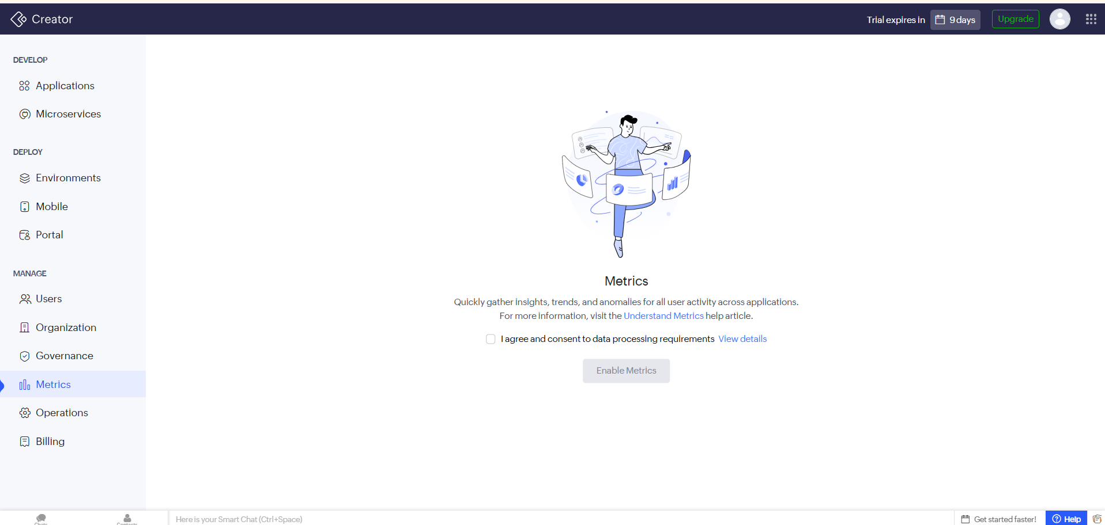

Purpose
The Metrics module in Zoho Creator enables organizations to monitor and analyse user activity across applications. It provides valuable insights into application usage, user behaviour, trends, and anomalies, helping administrators make informed decisions based on operational data.

Description
The Metrics interface is designed to collect and process activity data from applications within the Zoho Creator environment. Once enabled, it gathers information related to user interactions and system usage, allowing administrators to understand how applications are being used over time.
The module helps identify usage trends, detect unusual activities or anomalies, and evaluate user engagement across different applications. Before enabling Metrics, administrators are required to provide consent for data processing in accordance with Zoho's privacy and compliance requirements. This ensures that usage analytics are collected transparently while adhering to data protection standards.

Key Functions
- Monitor user activity across applications.
- Analyse usage trends and behavioural patterns.
- Detect unusual activities and anomalies.
- Generate insights to support decision-making.
- Enable centralized application usage analytics.

Benefits
- Provides data-driven insights into application usage.
- Helps identify user engagement and adoption trends.
- Detects abnormal activities for improved monitoring.
- Supports informed business and administrative decisions.
- Enhances application performance evaluation and optimization.

Business Use Case
A company using Zoho Creator for multiple business applications can enable Metrics to monitor employee interaction with each application. Administrators can analyse which applications are frequently used, identify inactive modules, detect unusual login patterns, and use these insights to improve application performance, user experience, and overall operational efficiency.

Feature Name : Operations
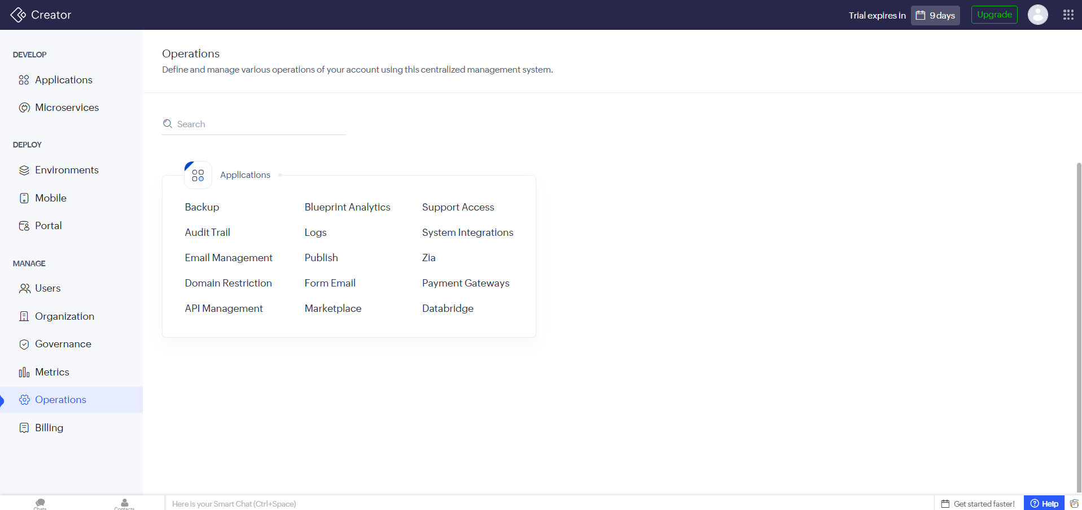

Purpose
The Operations module in Zoho Creator serves as a centralized management hub for configuring, monitoring, and maintaining various operational aspects of an organization's applications. It provides administrators with tools to manage backups, security, integrations, logs, publishing, and other essential system operations.

Description
The Operations interface consolidates a wide range of administrative functions into a single location, enabling efficient management of the Zoho Creator environment. It includes operational modules such as Applications, Backup, Audit Trail, Email Management, Domain Restriction, API Management, Blueprint Analytics, Logs, Publish, Form Email, Marketplace, Support Access, System Integrations, Zia, Payment Gateways, and Databridge.
By centralizing these management tools, administrators can perform system maintenance, monitor application activities, configure integrations, manage communication settings, and ensure the secure and reliable operation of business applications. This unified interface simplifies administrative tasks while improving overall governance and operational efficiency.

Key Functions
- Manage application operations from a centralized interface.
- Configure backups, audit trails, and system logs.
- Manage APIs, integrations, and email settings.
- Control publishing, marketplace, and support access.
- Configure payment gateways, Zia services, and Databridge connections.

Benefits
- Centralizes administrative and operational management.
- Simplifies application maintenance and monitoring.
- Enhances security through audit and logging features.
- Supports seamless integration with external services.
- Improves system reliability, governance, and operational efficiency.

Business Use Case
An organization managing multiple business applications can use the Operations module to schedule backups, monitor audit logs, configure API integrations, manage email notifications, publish application updates, and integrate payment gateways from a single dashboard. This centralized approach reduces administrative complexity while ensuring secure and efficient application management.

Feature Name : Billing
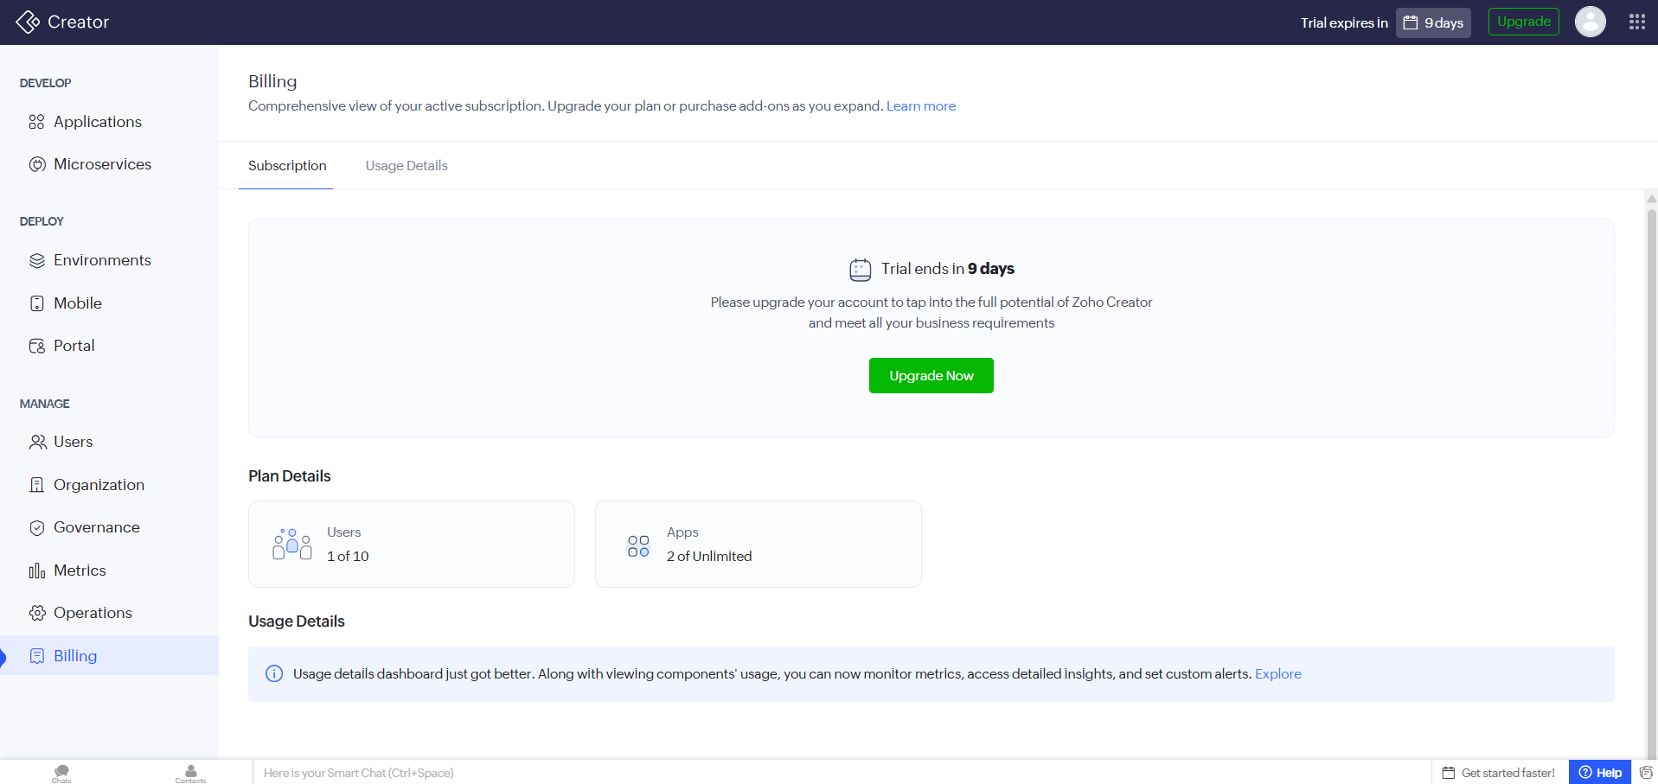

Purpose
The Billing module in Zoho Creator provides administrators with a comprehensive overview of the organization's subscription, resource usage, and licensing details. It enables users to monitor their current plan, track resource consumption, and upgrade their subscription as business requirements grow.

Description
The Billing interface acts as the central location for managing subscription-related information. It displays details such as the current subscription status, trial period, plan information, and allocated resources, including the number of users and applications. Administrators can also view the remaining trial period and upgrade their subscription to access advanced Zoho Creator features.
The module includes a Usage Details dashboard that provides insights into resource utilization, allowing administrators to monitor application components, usage metrics, and system consumption. It also supports custom alerts to help organizations proactively manage resource limits and optimize subscription usage.

Key Functions
- View subscription and plan details.
- Monitor user and application usage.
- Track trial period and subscription status.
- Access detailed usage metrics and resource insights.
- Upgrade the subscription plan and purchase additional add-ons.

Benefits
- Provides complete visibility into subscription and licensing information.
- Helps monitor resource usage and avoid exceeding allocated limits.
- Supports informed decisions when upgrading plans or purchasing add-ons.
- Improves resource management through detailed usage analytics.
- Enables proactive monitoring using usage insights and custom alerts.

Business Use Case
A growing organization initially starts with a trial subscription to develop internal business applications. As the number of users and applications increases, administrators use the Billing module to monitor resource consumption, review subscription limits, and upgrade to a suitable plan that supports additional users and advanced platform features.

